# Assembling the S±E upgrade kit

This is only a very rough guide through the assembly process. Not fool proof. Common sense required.

1. Equip the printed parts with M3 nuts

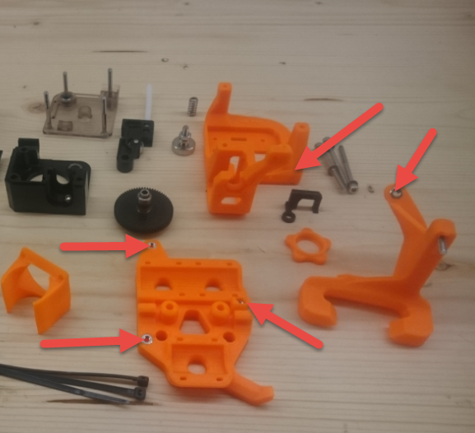

1. Disassemble the original extruder

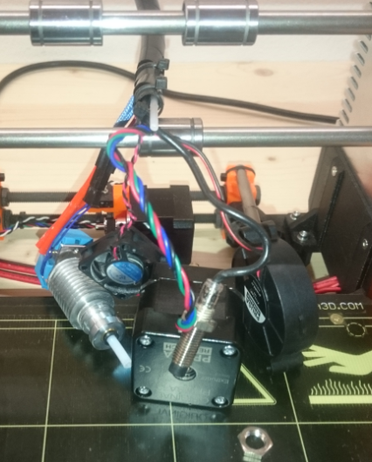

1. Uplug the motor from the board and feed the plug through the x-rods

For this S±E kit, all cables will be fed beneath both x-rods. Since the motor itself is too big tob e fed through the x-rods, this action is necessary.

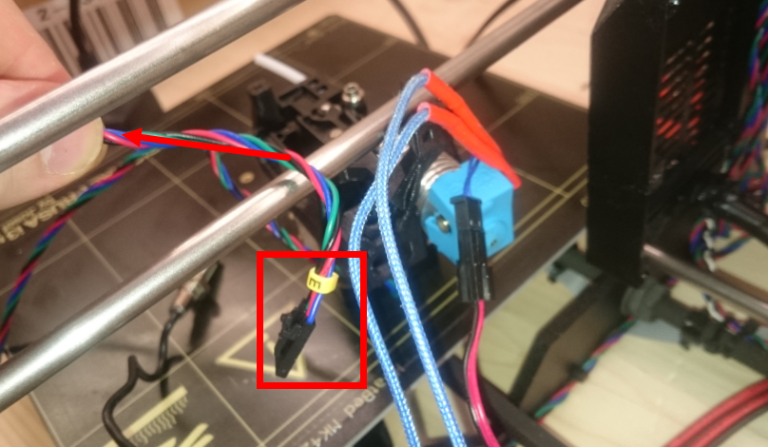

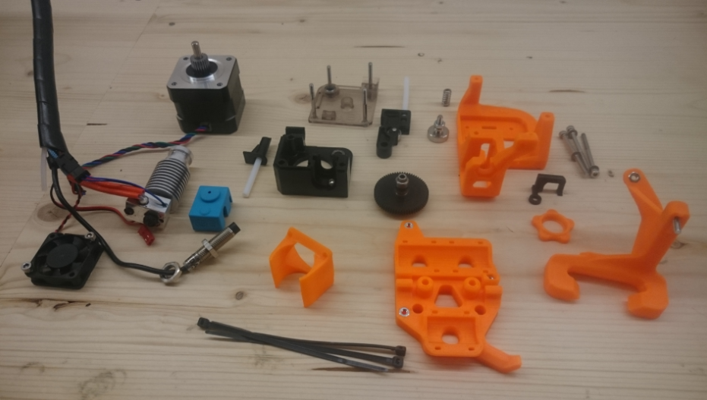

1. Mount the x-carriage to the x-rods

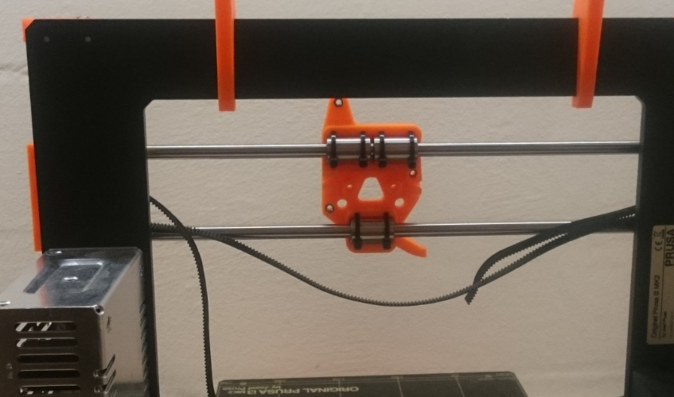 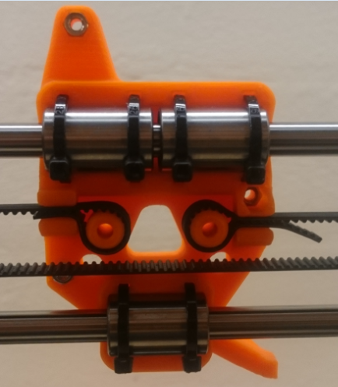

1. Assemble Titan to extruder mount

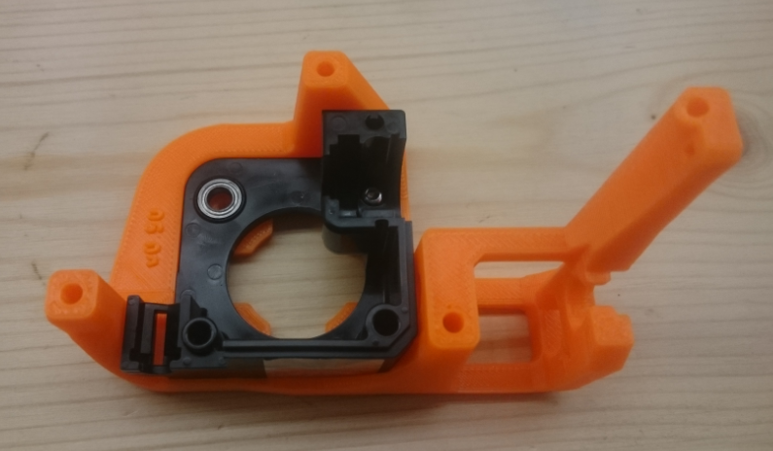

1. Preassemble indicator to Titan cover

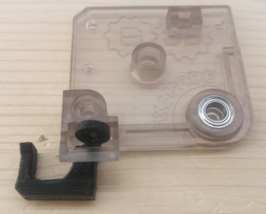 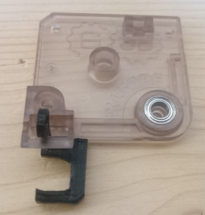

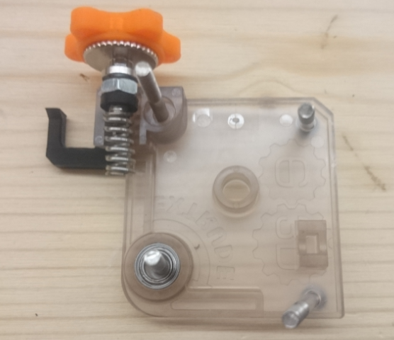

1. Preassemble Hotend

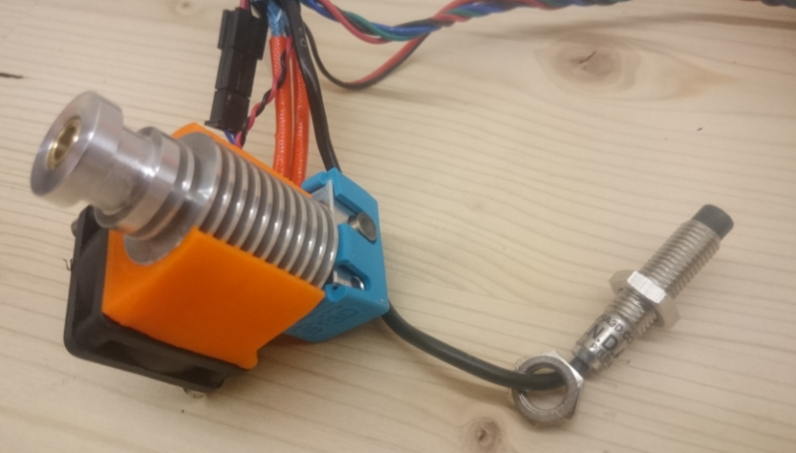

1. Assemble hotend with extruder mount, motor

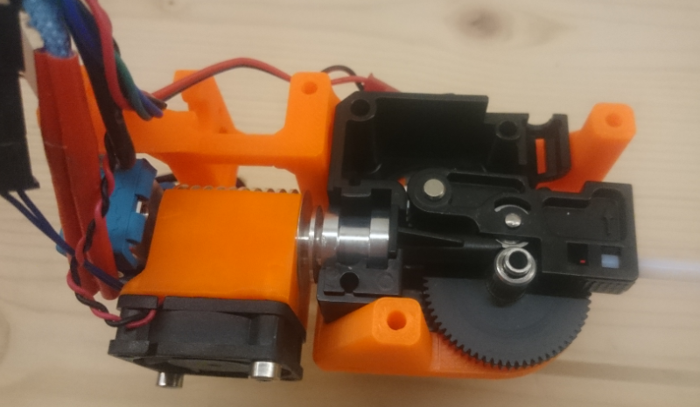 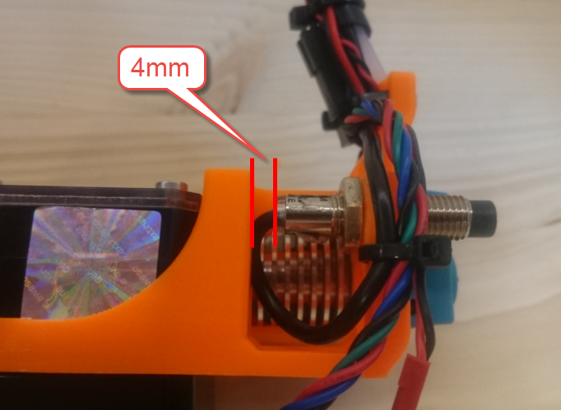

Gap between PINDA and extruder mount approx. 4mm.

1. Mount cover

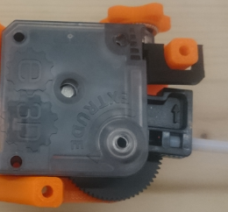

1. Tighten cable ties. Have a proper cable management

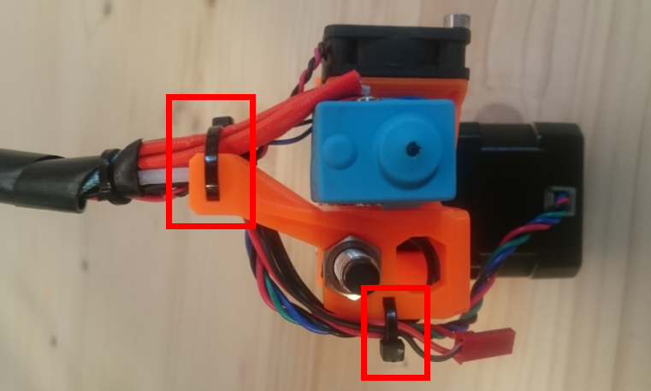

1. Pressemble fan mount

It’s useful to have a plug for the nozzle fan, but it’s not necessary.

Option 1 : Original radial fan. M3x16 / M3x20 Option 2: Axial fan 40x40

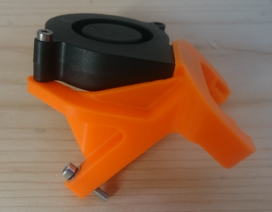 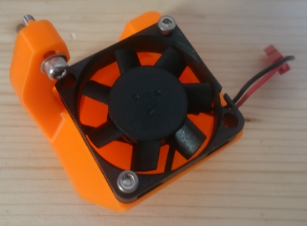

1. Prepare 3 xM3x40. Mount whole extruder assemlby and fan mount of your choice.

